Verification for Exercise 2.19 using MATLAB and Inverse Laplace (ilaplace):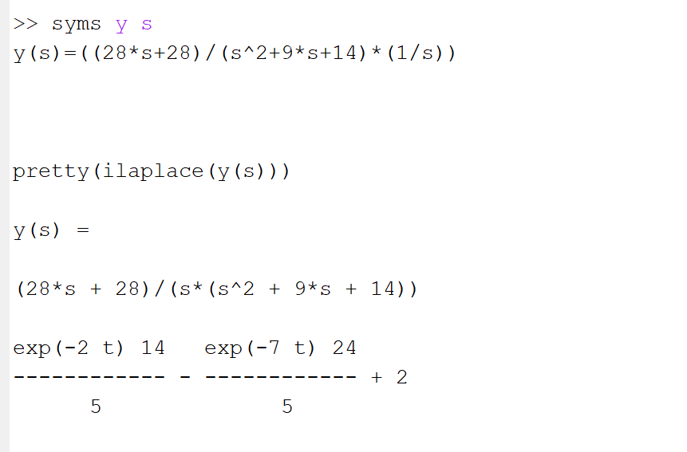

Verification for Exercise 2.30 Using MATLAB and Inverse Laplace (ilaplace):



